UI Design and Prototyping Report Template

### Project Name: Primícia Modas

1. Introduction

My project consists of making a virtual showcase to display the crochet products that my mother makes and sells in her store. My goal is to achieve more visibility and reach a greater number of people and thus help my mother with her sales.

2. User Interface Design and Prototype

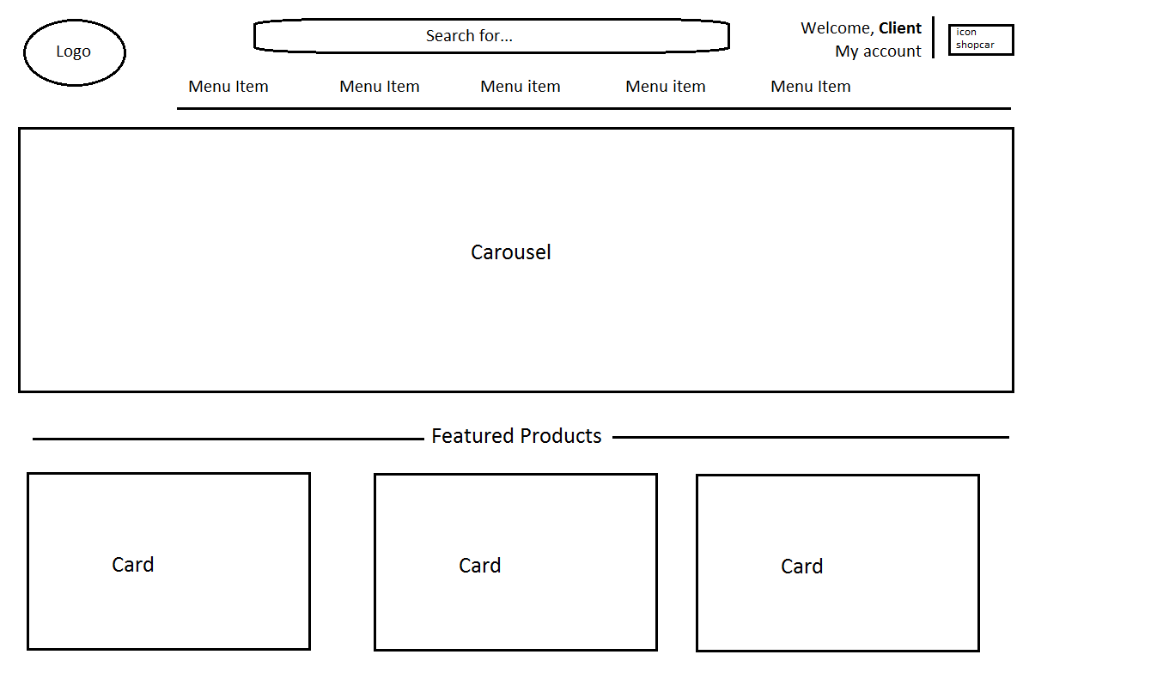

In this design, I was able to include a search box, menus that will direct the user to more pages, a product carousel and a section of featured products that will be displayed on cards.

3. Navigation Structure

3.1. The idea is that the user, when accessing, can see the featured products and navigate between the departments of the products and thus locate what is of interest to them.

3.2. The user, when locating your product, will add it to the cart if it has stock, or request an order where the deadline for it will be shown.

4. Reference

The site I used as a model was:

https://www.yarn.com/